Platform Governance
Summary:
The purpose of this report is to document the deployment, configuration and testing of the Wazuh Security Information and Event Management (SIEM) platform within a virtualised Security Operations Centre (SOC) lab environment. The project focused on implementing centralized security monitoring, File Integrity Monitoring (FIM), vulnerability detection and alerting capabilities to simulate real-world Blue Team operations. The deployment included the configuration of the Wazuh Manager, Dashboard, Indexer and endpoint agents across segmented virtual networks using Hyper-V virtualisation. Testing was conducted to validate agent communication, alert generation and security monitoring functionality.
This report applies to the implementation and testing of SIEM technologies used for cybersecurity monitoring, threat detection and SOC training purposes within the SWERI cybersecurity environment.

Document Type: Technical Deployment & Testing Report
Document: Wazuh-SIEM-001
Version: 1.0
Change Request No: CN0001
Date Implemented: 4/06/2026
Created By: Gleb Verlan and Harrison Tod
Approved By: Dr Ala Al-Areqi

- PURPOSE

The purpose of this report is to document the deployment, configuration and testing of the Wazuh Security Information and Event Management (SIEM) platform within a virtualised Security Operations Centre (SOC) lab environment. The project establishes a centralized monitoring environment capable of detecting, analysing and responding to cybersecurity events across multiple systems and endpoints.
This report defines the deployment architecture, monitoring capabilities and testing procedures used to validate Wazuh functionality. It ensures visibility into system activity, file integrity changes, vulnerability detection and alert generation through a structured and controlled environment.
The project also provides practical experience in Blue Team operations, SIEM deployment, Linux administration and cybersecurity monitoring practices within a simulated enterprise network environment.

- SCOPE

This report applies to the deployment and testing of the Wazuh SIEM platform within a Hyper-V virtualised lab environment. The scope includes the configuration of the Wazuh Manager, Indexer, Dashboard and endpoint agents across Linux and Windows systems.
The environment encompasses:
- Virtual machine deployment and configuration
- Internal and external segmented network architecture
- Agent-to-manager communication
- Log collection and analysis
- File Integrity Monitoring (FIM)
- Vulnerability detection and CVE scanning
- Real-time alerting and dashboard monitoring
The lab environment was segmented into:
- Internal network (172.20.0.0/24) for SIEM communication
- External network (10.3.x.x) for internet connectivity and simulated external access
A dedicated gateway virtual machine was configured using NAT, port forwarding and firewall routing rules to securely forward traffic between networks while maintaining isolation of the internal SIEM infrastructure.
This project supports cybersecurity monitoring, SOC training and defensive security operations by simulating real-world enterprise monitoring environments and testing detection capabilities against security events and system activity.

- DEFINITIONS

Security Information and Event Management (SIEM): A cybersecurity solution that collects, analyses and correlates security logs and events from multiple systems and endpoints to provide centralized monitoring, threat detection and incident response capabilities.
Wazuh: An open-source SIEM and Extended Detection and Response (XDR) platform that provides log analysis, intrusion detection, File Integrity Monitoring (FIM), vulnerability detection and security alerting functionalities.
File Integrity Monitoring (FIM): A security monitoring process that detects changes to files, directories and system configurations by monitoring file hashes, permissions and modifications to identify unauthorized or suspicious activity.
Vulnerability Detection (CVE Scanning): A security feature used to identify known vulnerabilities within installed software and operating systems by comparing system information against vulnerability databases such as the National Vulnerability Database (NVD).
Agent: Software installed on endpoint systems that collects logs, system events and security data before securely forwarding the information to the Wazuh Manager for analysis.
Wazuh Manager: The central component responsible for processing logs, applying detection rules, generating alerts and managing connected agents within the SIEM environment.
Wazuh Dashboard: A web-based interface used for visualising alerts, monitoring endpoint activity and analysing security events in real time.
Security Operations Centre (SOC): A centralized environment responsible for monitoring, detecting, analysing and responding to cybersecurity threats and security incidents across an organisation’s infrastructure.
Network Address Translation (NAT): A networking process used within the gateway virtual machine to route and translate traffic between the internal and external networks while maintaining network isolation and controlled communication.

- SYSTEM ARCHITECTURE / ENVIRONMENT

The Wazuh SIEM environment was deployed within a Hyper-V virtualised lab environment designed to simulate a real-world Security Operations Centre (SOC). Ubuntu Server was used for the Wazuh Manager deployment, while both Linux and Windows systems were configured as monitored endpoints through Wazuh agents.
The lab environment was segmented into two separate networks to improve security and simulate enterprise network architecture:

• Internal network (172.20.0.0/24) used for communication between the Wazuh Manager and agents.
• External network (10.3.x.x) used to provide internet connectivity and simulate external access.

A dedicated gateway virtual machine was configured with two network interfaces to act as a bridge between the internal and external networks. Network Address Translation (NAT), port forwarding, IP forwarding and firewall routing rules were implemented to securely route traffic between networks while maintaining isolation of the internal SIEM infrastructure.

The following ports were configured for Wazuh communication:
Port | Protocol | Purpose
1514 | TCP | Agent-to-manager log communication
1515 | TCP | Agent authentication
This architecture simulated a segmented enterprise monitoring environment and improved understanding of secure network design principles.

Wazuh Component Roles
Component | Role
Wazuh Manager: | Processes logs, applies detection rules and generates alerts
Wazuh Indexer: | Stores and indexes log data for querying and analysis
Wazuh Dashboard: | Provides a web-based interface for visualising alerts and monitoring activity
This separation of components follows standard SIEM architecture and enterprise security monitoring practices.

- WAZUH DEPLOYMENT

5.1 Installation
The Wazuh Manager was installed on an Ubuntu Server virtual machine within the Hyper-V environment. The deployment process included operating system configuration, network setup and execution of the Wazuh installation script to deploy the Wazuh Manager, Indexer and Dashboard components.
The Wazuh Dashboard was accessed through a web browser using the server IP address. System functionality was validated by checking service status and confirming successful dashboard access.
5.2 Agent Deployment
Wazuh agents were deployed on both Linux and Windows endpoint systems. The deployment process involved installing the Wazuh agent software and configuring each agent to communicate with the Wazuh Manager using the server IP address.
The agents forward logs, system events and security information to the manager for analysis and alert generation. Successful deployment was verified by confirming active agent status within the Wazuh Dashboard.
5.3 Data Flow
Step | Data Flow Process
1 | Agents collect logs and system data from endpoints
2 | Data is securely sent to the Wazuh Manager
3 | Detection rules process and analyse events
4 | Processed data is forwarded to the Indexer
5 | The Dashboard visualises alerts and monitoring data
This pipeline enables centralized monitoring and real-time threat detection across the environment.

- FEATURES CONFIGURED

6.1 Log Monitoring
Log monitoring was configured to collect and analyse system and security logs from endpoint systems. This provided visibility into system activity and assisted with identifying suspicious behaviour such as authentication failures, privilege escalation attempts and abnormal system events.
6.2 File Integrity Monitoring (FIM)
File Integrity Monitoring was implemented to monitor critical system directories and files for unauthorized modifications. The feature tracks file hashes, permissions and modifications to detect suspicious activity, malware behaviour and insider threats.
Alerts are generated whenever monitored files are changed or modified outside expected behaviour.
6.3 Vulnerability Detection (CVE Scanning)
The Wazuh vulnerability detection module was configured to identify known vulnerabilities within installed software and operating systems. The module compares installed packages against vulnerability databases including the National Vulnerability Database (NVD).
Testing identified multiple Common Vulnerabilities and Exposures (CVEs), demonstrating the effectiveness of the vulnerability scanning functionality.
6.4 Alerting & Dashboard
Wazuh alerting was configured using predefined detection rules. Alerts are generated whenever suspicious or abnormal activity is detected and are displayed within the Wazuh Dashboard in real time.
The dashboard provided centralized visibility into endpoint activity, alerts, vulnerabilities and monitored system events.
7. TESTING PHASE
Testing was conducted using structured scenarios to validate functionality and monitoring capabilities.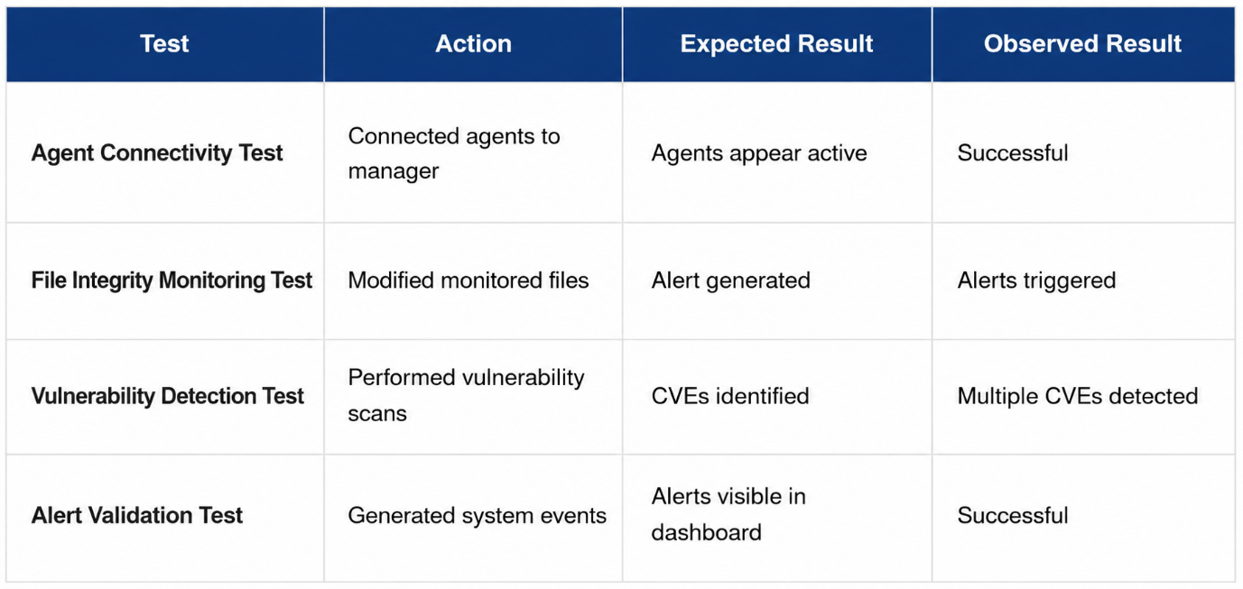

Overall testing confirmed that core SIEM functions were operational and capable of monitoring and detecting security-related events.

8. CHALLENGES & ISSUES
Several technical challenges were encountered during the deployment and testing process
- Insufficient virtual disk space requiring resizing and repartitioning of disks
- Network configuration issues between virtual machines
- DNS and connectivity problems
- Dashboard access timeout issues
- Agent communication failures
These issues were resolved through troubleshooting, network reconfiguration, log analysis and iterative testing. Resolving these challenges improved understanding of enterprise networking, SIEM infrastructure and cybersecurity monitoring environments.

9. RESULTS / FINDINGS
The project successfully deployed a functional Wazuh SIEM environment with active monitoring and alerting capabilities. The deployment demonstrated effective centralized monitoring, vulnerability detection and endpoint visibility.
The Wazuh platform successfully detected file changes, vulnerabilities and suspicious activity while generating real-time alerts through the dashboard interface.
The results confirmed that Wazuh is a flexible and effective open-source SIEM solution suitable for SOC operations, cybersecurity monitoring and security analysis.

10. SKILLS & LEARNING OUTCOMES

The project provided practical experience and technical knowledge in the following areas:
- SIEM deployment and configuration
- Linux system administration
- Virtual machine deployment and networking
- Security monitoring and alert analysis
- Log analysis and threat detection
- Network troubleshooting and connectivity management
- Practical SOC operations and Blue Team workflows
The deployment significantly improved understanding of enterprise cybersecurity monitoring environments and defensive security operations.

11. FUTURE IMPROVEMENTS
Several improvements could further enhance the environment:
- Expand agent deployment to simulate larger enterprise infrastructure
- Improve SIEM scalability and performance monitoring
- Tune detection rules to reduce false positives
- Implement advanced threat simulations
- Integrate external threat intelligence feeds
- Improve dashboard customization and reporting

These improvements would strengthen monitoring capabilities, detection accuracy and scalability.

12. CONCLUSION

The Wazuh SIEM platform was successfully deployed and tested within a Hyper-V virtualised SOC lab environment. The deployment demonstrated strong capabilities in centralized monitoring, File Integrity Monitoring, vulnerability detection and security alerting.
The project provided valuable hands-on experience in SIEM technologies, Linux administration, network troubleshooting and defensive cybersecurity practices.
Overall, the environment successfully simulated real-world SOC operations and established a strong foundation for future cybersecurity monitoring and security analysis projects.

